Meeting Agenda – 2020.06.23
NYC/NJ Christian Businessmen

Stuff to talk about
- How are you? How is your walk with God?
- What was most impactful to you during the two meetings with Tim Philpot / Bob Doll?
- How has God been speaking to you? Community outreach, BLM… Rich, Ricky, anyone else.
  - We don’t need to make any decisions today, but hear out the brothers, and see where God leads us
- Schedule for future meetings. We should keep our schedule for now.
- Discuss weekly prayer meeting and best time for it
  - I want you to be involved! For your businesses/work/life’s direction/etc.. for others.. for joint pursuits, and wherever God calls us!

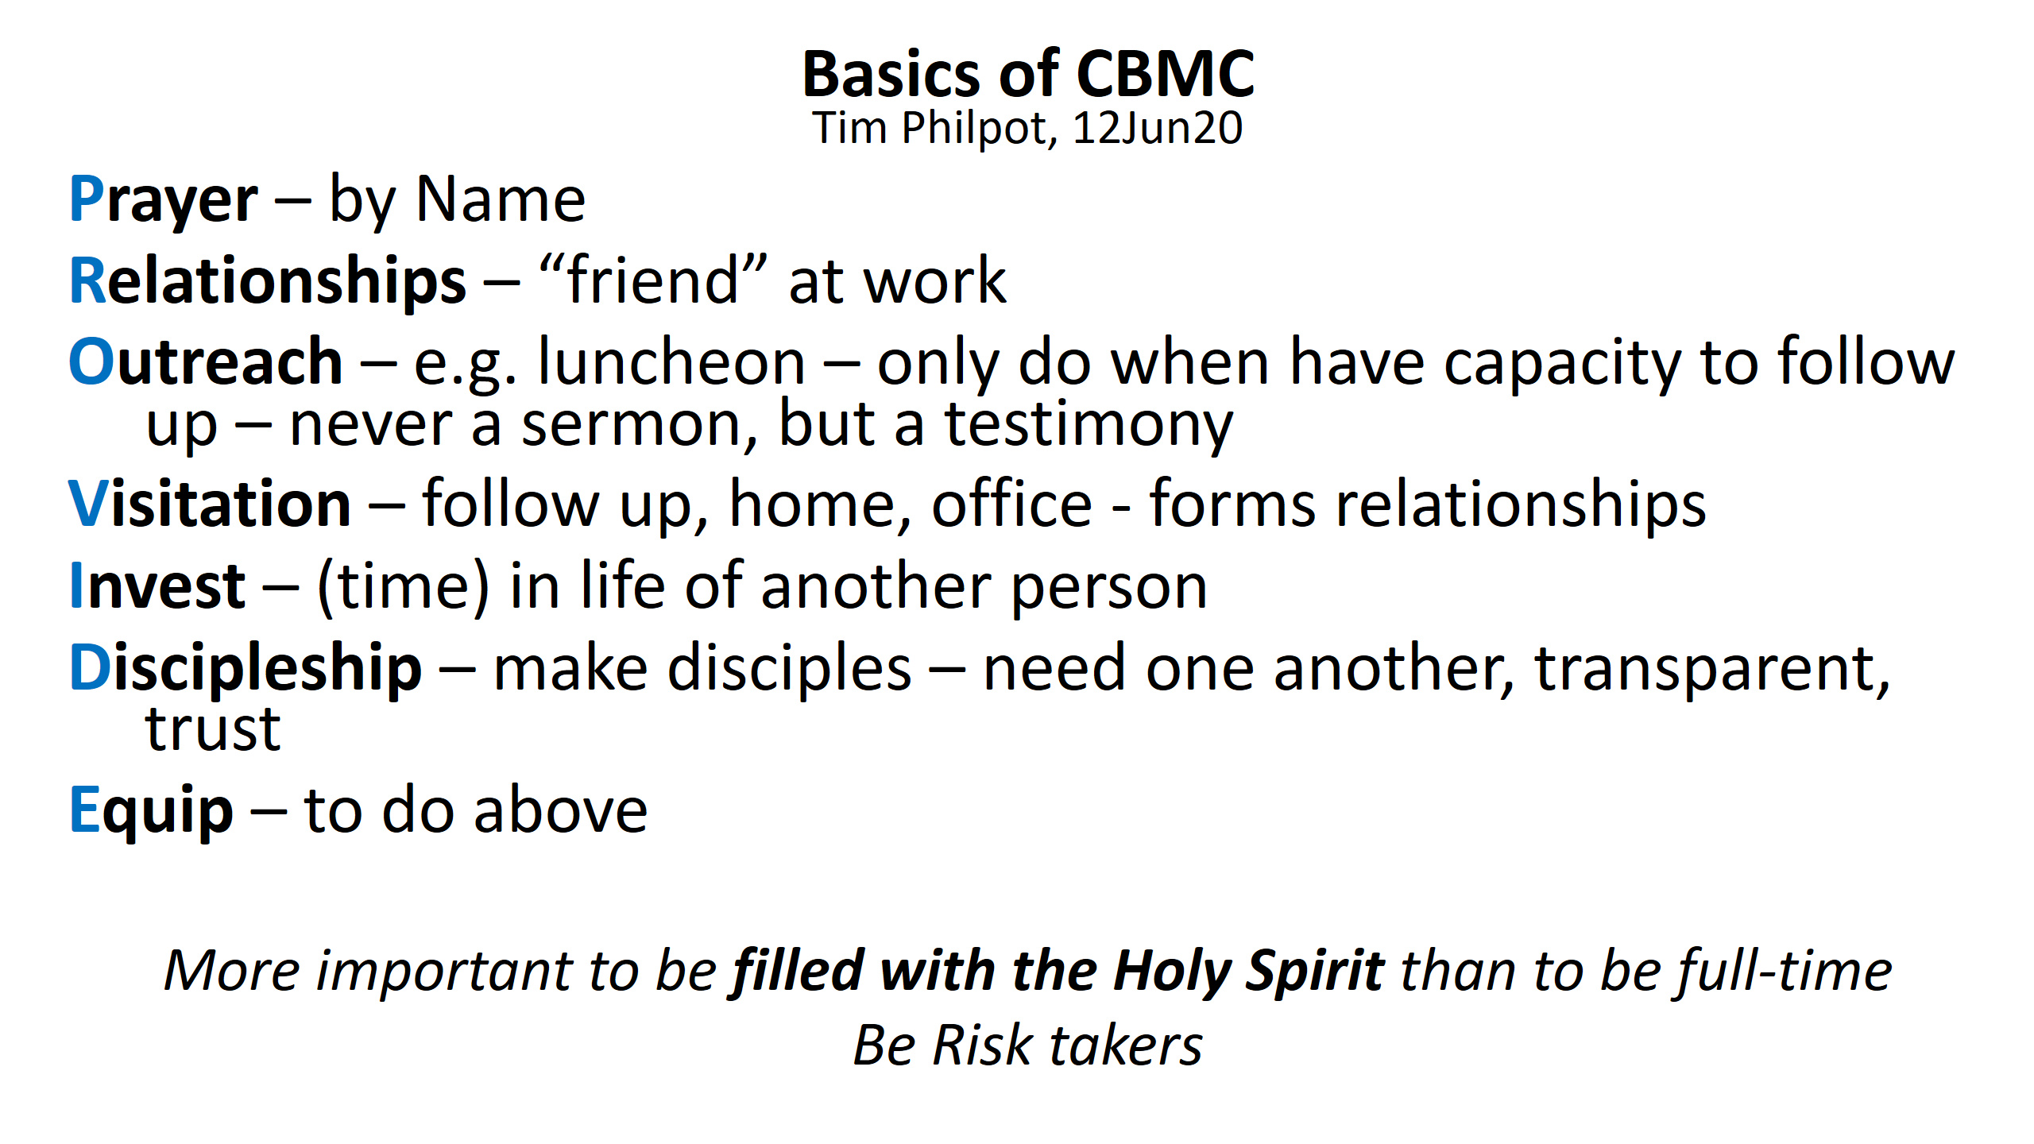Known Schedule conflicts
- Edward Lee (7pm store close M-F)
- Marcello(8:30pm store close Tues,Wed, Thurs – Available M, F, Sat)
- Rich
- David (Tues, Thurs evenings blocked)
- Anyone else less flexible?

Notes from Speakers
Tim Philpot

- Take risks in the pandemic. To where has God been directing you – both personally, or toward us, or others?

Bob Doll

Ten Spiritual Reminders:
- Remember God is sovereign
- Don't worry, don’t be anxious
- God owns it all
- Tread lightly in this world – simplify your life (don’t be busy)
- Make a wise plan and rely on God
- Coronavirus exposes idols... name them and deal with them
- Give generously... in time, money, intellectual, and physical capability
- Turn inward fears to outward focus
- In all things, give thanks... be content (Paul wrote this from prison)
- Live out your faith – do our actions back up our beliefs? - the world is watching us

Corporate Help
- Be flexible and humble – stay empty
- Be genuine, Communicate (can’t make it out)
- Focus on the main thing, such as clients or customers, don’t be distracted
- Be calm and be consistent, esp as a leader
- Rely on wise counsel - get advice from others

To Do
In thought:
- Acknowledge God
- He is on the throne
- He owns it all
- We are just passing through
- Be calm / be still / pray - Panicking won't help anyone
- Express gratitude to Got and to others
- Meditate on psalms (highs and lows) – 31, 46, 69, 77, 91
- Express hope, believe hope, learn to hope – for yourself and for others

5 practical to dos
- Be productive... read books and complete the project you had
- Turn the tv off - be informed, not mesmerized
- Reach out to others – 2/3 phone calls a day
- Serve others
  - take a meal to someone, especially the elderly
  - give – church, help start a non-profit, rescue mission
- Take a break – go for a walk, work out, take a bike ride

- Grateful to God
- Recognize brevity of life

When Bob Doll had difficult times
- Concept of "Child of God" went down the list... bc work took priority
- Maybe we should let God be in control!
- Relying on other Christians - Prayed for me, asked me questions... I recognized the need the body of Christ

